**Activity – Project Management for Greenwich University**

Recent developments demand to continuously improve to be able to stay competitive and relevant. Education is one sector that needs to lead in this game, so as students of Managements Skills, you need to propose a new system for UoG.

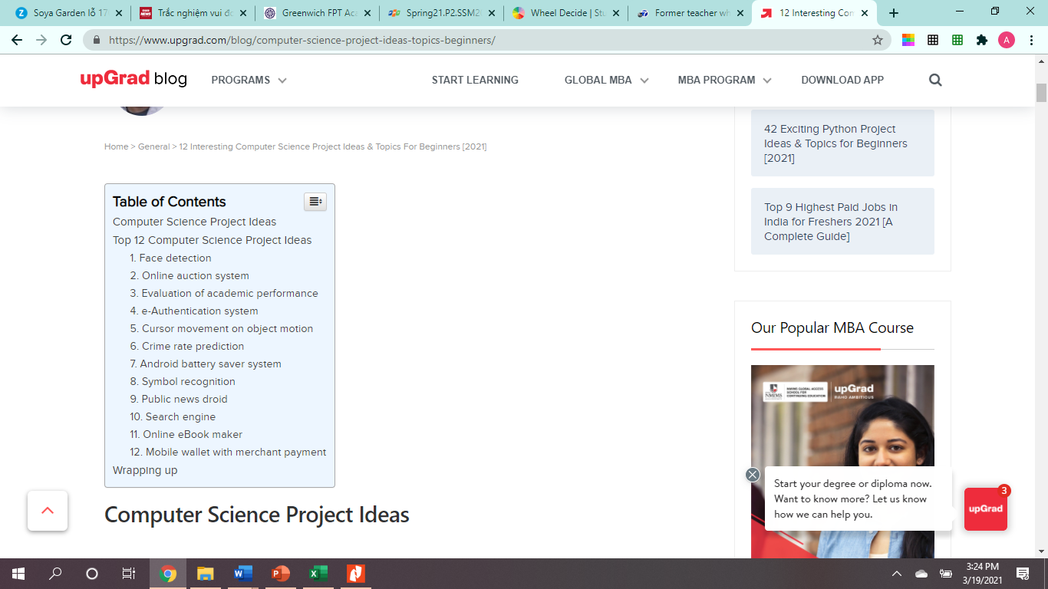You can choose any technical system for the school, but I have also included some list to give an idea on what projects you can do for this subject.

**Tasks:**

1. Look around the school and look for a technical system that we need or can be improved that will benefit the school, students, teachers and staff.
2. Prepare a presentation that outlines below:

* Cover
* Background of the school – history, stakeholders, Vision, Mission, Values, growth
* Products/Services
* Marketing Strategies that we do
* Operations and Management – enrollment, testing, grades, schedules, security etc
* HR
* Or other related/necessary for the project that you want to propose
* Your proposal – why this is important for UoG to have – advantages
* Plan – implementation, materials needed, people involved, timeline, rough budget and how you will control and monitor this project to ensure that this will be useful and working for UoG

|  |  |  |  |
| --- | --- | --- | --- |
| **Task** | **Timeline** | **Budget** | **Control and Monitoring** |
|  |  |  |  |